It’s “Pirate Run” weekend!

Western Agility Group  June 12-14, 2026  WAG, Inc. (Western Agility Group)  10925 Bruceville Road, Elk Grove, CA  Judge – Roger Coor  Phoenix, AZ  Double Run Format  Building and Ring Surface info:  Dirt Ring under Cover  80x100  and  Lawn  90x100  Contact Surface:  Rubber  Crating Set up times:  Friday – 9:00AM  Saturday and Sunday - 7 AM  Walking at:  Friday – 9:00 AM  Saturday and Sunday - 7:00 AM  First dog on the line at:  Friday – 9:30 AM  Saturday and Sunday - 7:30 AM | 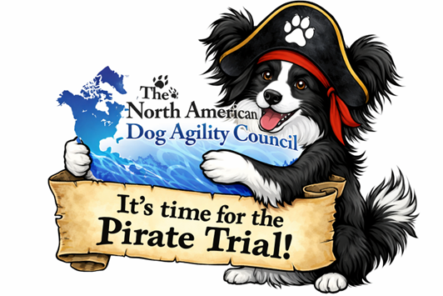  Preliminary Class Run Order:  May change depending on weather, judge’s preference, time or number of entries.  Classes in tan are held in the covered arena and those in green will be held on the lawn.  Friday  Saturday  Sunday  Pirate Runs Weekend!    If you are looking for a fun challenge with an opportunity to win some Pirate Booty – check out Pirate Runs!  Details in confirmation and final show email.
  Class: | Double Run Format  # of Rounds
  Tunnelers | 2
  Chances | 2
  Jumpers | 2
  Gamblers | 2
  Class: | Double Run Format  # of Rounds
  Regular | 2
  Jumpers | 2
  Touch N Go | 2
  Weavers | 2
  Class: | Double Run Format  # of Rounds
  Chances | 2
  Regular | 2
  Jumpers | 2

Entries Open:  Immediately  Closes on:  June 9th, 2026  or if trial fills  Crating available:  Indoor and outdoor space  Entry Limits:  500 runs a day  Move ups:  Move Ups are allowed from day to day.  No Same Day Move Ups.  Day of show Entries:  Pre-Enter for Discount!  Accepted at Full Price if Trial is not full.  Confirmations:  Confirmations will be emailed on or before June 9th  Refunds:  After the closing date, no entry fees will  be refunded for dogs pulled from the Trial.  Bitches that come into season before Thursday of the Trial Week will receive a 50% Refund.  Equipment info:  Equipment provided by WAG, Inc. | Show Committee  Trial Chair: Dave Scheuner  Secretary: Susan Rappillus  Chief Ring Steward: TBA  Chief Course Builders: TBA  Chief Scorekeeper: Justine Bradley  Food Info:  Worker water and various packaged snacks will be offered by the club – please bring all you will need for yourself and your dog during the event.  Volunteer info:  Volunteers will earn tickets for a  Worker Drawing pulled each day.  Awards and Ribbons:  Ribbons will be given 1st through 4th Place. Qualifying Ribbons will be given for Qualifying Rounds.  CELEBRATIONS!!  If you might earn a NATCH at this trial, please let us know, so we can be prepared to celebrate with you!  Whether it's a 1st or subsequent NATCH, please let us know your intentions so we can have the appropriate items available: just a celebration, a celebration + ribbon, a celebration + pole, or a celebration + ribbon+ pole  1st NATCH’s of any type earn you a complimentary NATCH pole. For subsequent NATCH’s, the club will have poles available for purchase ($6). NATCH ribbons are always complimentary upon earning any NATCH.

Jump Height Info:

MEASURING
Measurement forms and more info may be obtained at:
www.nadac.com. Click on “Data Center”. Scroll down to “Permanent Height Card”.

All dogs 2 years of age and older are required to have a Permanent Height Card to compete.
(effective Jan.1, 2025)

JUMP HEIGHTS
There are four Standard Division-Proficient jump heights: 8”, 12”, 16”, and 20”.
There are four Standard Division-Skilled jump heights: 4”, 8”, 12”, and 16”.
There are four jump heights for the Veterans and Junior Handler divisions: 4”, 8”, 12”, and 16”. Please see the NADAC Rulebook for the full jump height table

Brief Summary of Rules:
Please refer to www.nadac.com for a full explanation of all NADAC rules and up to date information.
- Please note that NADAC trials should provide a safe and fun environment for both exhibitors and their dogs.
- Aggressive dogs will not be tolerated and will be excused from the trial.
- The show committee has the right to refuse any entry. Anyone not currently in good standing with NADAC will not be allowed to enter this trial.
- Exhibitors, through submission of entry, acknowledge that they are knowledgeable of NADAC rules and regulations, and agree to abide by all rules in effect at the time of this trial.
- No entry fee will be refunded if the trial cannot open or be completed by reasons of riots, civil disturbances, fire, acts of God, public emergency, an act of a public enemy, or any other cause beyond the control of the organizing committee.
- Checks not honored by the bank do not constitute a valid entry fee. There will be a $25.00 service charge for bank returned checks.
- Dog must be registered and have a valid registration number before entries will be accepted. New Handlers please register here: NADAC-New Handler-Dog Registration. If you already have a dog registered with NADAC or are a NADAC Associate, please visit the H&D Portal to register a new dog.
- A copy of the current Exhibitors Handbook may be downloaded free from the NADAC web site: www.nadac.com
- Bitches in heat, lame, or blind dogs are ineligible for entry, as is any dog with a deformity which may cause a judge to not be able to reasonably assess the dog’s ability to function and perform agility obstacles safely, and in a manner that is in the best interest, health and welfare of the dog.
- No food, clickers, or other aids or devices shall be permitted on the course or within 10 feet of the ring. Food or a small non-audible toy can be in a secure container (zip-lock bag is acceptable) in your pocket during your run but you cannot indicate to the dog it is there. All handlers may bring a non-audible toy into the ring for training purposes. They cannot earn a Qualifying score and must declare to the judge they are training before they commence their run. Please read the Exhibitor’s Handbook for more information about toys and training in the ring.
- The sponsoring clubs will not be responsible for the loss or damage to any dog exhibited, or for the possessions of any exhibitor whether the result be accident or other cause. It is distinctly understood that every dog at this event is in the care and control of his owner or handler during the entire time the dog is on the show premises.


Western Agility Group (WAG, Inc.), June 12-14, 2026
pre-entry pricing closes June 9th
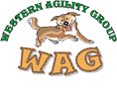
Make Checks Payable to: WAG, Inc.
Send entries to:
WAG, Inc. PO Box 581328, Elk Grove, CA 95758
Questions - Susan@k9wag.com
Owner |  |  |  |  |  | Dog
Name |  |  |  |  |  | Call Name
Address |  |  |  |  |  | NADAC Reg #
City/State/Zip |  |  |  |  |  | Date of Birth
Phone |  |  |  |  |  | Height at Withers
Email |  |  |  |  |  | Breed
Handler, If not owner |  |  |  |  |  | Permanent Height Card on file with NADAC?  Yes No
Emergency Contact Name/Phone
PLEASE INCLUDE A COPY OF YOUR DOG’S HEIGHT CARD IF YOU DO NOT HAVE ONE ON FILE.
CATEGORY: PROFICIENT SKILLED
DIVISION: STANDARD VET DOG VET HANDLER JUNIOR HANDLER
I WANT MY DOG TO JUMP: 4 8 12 16 20
Class | Level |  |  |  |  | Day
Class | Intro | Novice | Open | Elite |  | Friday | Saturday | Sunday
Regular |  |  |  |  |  |  | Rd 1  Rd 2 | Rd 1  Rd 2
Chances |  |  |  |  |  | Rd 1  Rd 2 |  | Rd 1  Rd 2
Jumpers |  |  |  |  |  | Rd 1  Rd 2 | Rd 1  Rd 2 | Rd 1  Rd 2
Gamblers |  |  |  |  |  | Rd 1  Rd 2
Touch n Go |  |  |  |  |  |  | Rd 1  Rd 2
Tunnelers |  |  |  |  |  | Rd 1  Rd 2
Weavers |  |  |  |  |  |  | Rd 1  Rd 2
PRICING: 1-6 runs  7-12 runs  13-18 runs  18-23 runs  24+ runs  JR. Handler  After closing & Day OF  All Runs are |  |  |  |  | $16/run  $15/run  $14/run  $13/run  $12/run  $7/run  $16/run |  | TOTAL runs: _______ X  Price per Run__________  $________  TOTAL Fees Paid $ ___________
In consideration of the acceptance of this entry, I/we certify that I/we have knowledge of, and are familiar with, and agree to abide by, the Rules and Regulations of NADAC in effect at the time of this trial, and by any additional rules and regulations as approved by NADAC for this trial. I/we certify that the dog entered is not a hazard to persons or other dogs. I/we further agree to be bound by the “Agreement” printed on page 6 of this premium

Owner/Exhibitor:_____________________________________________Date_____________________________
Parent or Legal Guardian of Junior Handler_______________________________________________________

AGREEMENT

The person who signs this agreement represents that he/she is authorized to enter into this agreement on behalf of both exhibitor and the owner of entered dog. In consideration of acceptance of this entry:

1.1. As used here "NADAC" means the North American Dog Agility Council, LLC., its members, officers, directors, employees, show chairs, show committees and agents.

1.2. Exhibitor/owner agree to abide by the rules and regulations of NADAC and any other rules and regulations appearing in the premium for this event.

1.3. Exhibitor/owner certify that the entered dog is not a hazard to persons, dogs or property and that the entered dog's rabies vaccination is current in accordance with the requirement of the state in which the dog resides.

1.4. Exhibitor/owner acknowledge all hazards presented by the event and the event premises, including, but not limited to, the condition of the surface, restrooms, security measures or lack of, electrical appliances, fittings, show rings, parking areas and the presence of unfamiliar animals and people; exhibitor and owner assume the risk of any harm arising from these.

1.5. Exhibitor/owner releases NADAC (including its respective officers, directors, employees, and members), WAG, Inc. (including its officers, directors, members, and event organizing committee), and will defend them and hold them harmless from all present and future loss, injury, damage, claims, demands and liabilities involving the entered dog, the event or event premises. Without limiting the generality of the foregoing hold harmless provisions, exhibitor/owner hereby specifically assumes sole responsibility for and agrees to indemnify and save the aforementioned parties harmless from any and all loss and expenses (including legal fees) by reason of the liability imposed by law upon any of the aforementioned parties for damages because of bodily injuries, including death, at any time in consequence of my (our) participation in this event, howsoever such injury or death may be caused and whether or not the same may have been caused or may have been alleged to have been caused by negligence of the aforementioned parties or any of their employees or agents or any other persons.

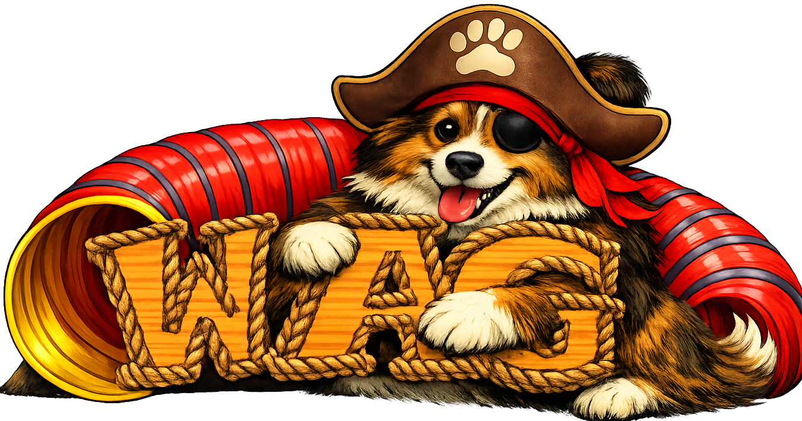

WAG FACILITY RULES

All exhibitors are subject to ejection for failure to comply

- Respect all the grounds - pick up after your dog at all times- everywhere on the property. Please pick up all your trash and dispose of properly. Do not allow your dogs to urinate anywhere on the buildings, garbage cans, or planters.
- Obey all speed and parking signs. Driveway speed is 5 MPH and will be enforced.
- Be aware of your dog and your immediate surroundings. Dog aggression will not be tolerated. No dog may be left tied up unattended - at any time.
- Respect the agility equipment and all of the facility buildings. Do not use equipment not in use by club.
- If there are problems/issues with the facility, please inform a club member and/or the facility owners.
- All children must be supervised at all times.
Directions and Camping Information:
WAG, Inc
10925 Bruceville Road
Elk Grove, CA

From Hwy 5 North or South: Take the Elk Grove Blvd exit & go East. Go approx 3 miles to Bruceville Rd & turn Right. Go approx 3.5 miles. Turn left in driveway at 10925 Bruceville Rd. WAG K9 Facility and Teeter Trail sign at driveway.

From Hwy 99 North or South: Take the Elk Grove Blvd exit & go West. Go approx 1 mile to Bruceville Rd & turn Left. Go Approx 3.5 miles. Turn left in driveway at 10925 Bruceville Rd. WAG K9 Facility and Teeter Trail sign at driveway.

On-Site: Overnight RV camping – By Reservation Only
Please download camping reservation form from the WAG website under premiums. Space is limited and will be reserved in the order received. There are 22 spaces total available. Electrical with water hookups are $35.00 per night. No hookups $15.00. Weekend tent camper $5.00
All campers must download and send in camping form direct to WAG
Find the form at www.k9wag.com in a link under the premiums/entries page
Or click HERE to take you to the Camping page

Motels that Accept Dogs

Extended Stay (916) 683-3753 - Elk Grove, CA,
Holiday Inn Express (916) 478-9000 - Elk Grove, CA, pet fee
Fairfield Inn & Fairfield Inn & Suites (916) 681-5400 - Elk Grove, CA pet fee
LaQuinta (916) 448-8100 - Sacramento, CA Dogs 50lb & under
LaQuinta (new) (800) 753-3757 – Galt, CA pet friendly Book super early.

Be sure to call ahead to verify pet policy – as things may have changed. Please help us and other dog fanciers keep our access to these hotels by being a responsible dog owner. Please show the proper respect for other people’s property and keep your dogs out of their bathtubs, cover the bedspread with one of your own sheets to keep down the amount of dog hair left behind, and please pick up after them. Thanks!!!

